The Rationale for Investing in a New BrewPub

Metropolitan College, Boston University
AD715 Quantitative and Qualitative Decision Making
Professor Dickson
Team 6: Fu Chen, Liuyi Chen, Di Ha, Danjie Qing, Zeyang Sun
Aug 4, 2021

Table of Contents
- Introduction
  - Problem Statement
  - Overall Goals and Objectives of the Report
  - Structure of the Report
- Managerial Decision Process for Selected Functional Areas
  - Marketing Management and Decision Making
  - Financial Management and Decision Making
- Application of Decision Support Tools per Functional Areas
  - Functional Area Marketing Management
    - SWOT Analysis
    - PESTELE Analysis
    - Tab-Sim-Report
  - Functional Area Financial Management
    - Break-Even Analysis
    - What-if Analysis
    - SWOT Analysis
References
Appendices

1. Introduction
1.1 Problem Statement
This report is conducted as a conceptual study by the owner of an existing restaurant, Toro Boston, as the rationale for investing in a new brewpub. Toro is a Spanish tapas restaurant and bar that has been serving the South End since 2005. The existing beverage program we have features classic-inspired cocktails and an eclectic, carefully curated wine list. For our future development, in order to increase the competitiveness and attract more customers, we would like to brew our own craft beer and sell it in-house. Due to the fact that investing in a new brewpub will lead to a $150,000 initial investment cost, we will make a thorough analysis from different functional areas, using quantitative and qualitative decision-making strategies, to decide whether we should invest in a new brewpub or not.
Our restaurant is located on the South End, near Northeastern University and Boston University Medical Campus. According to the earlier investigation, the target market may be identified based on three dimensions: location, age, and occupation. Regards to location, the most important one among three dimensions, our customers are mainly residents and students of/near the NEU Area. According to Massachusetts legislation, only individuals above the age of 21 are permitted to consume alcoholic beverages. Most of our customers are above 21 and would like to order a glass of wine or cocktail while having dinner. If we invest in a new brewpub, our target customers will still be able to order our own craft beer legally. Regards to our third dimension, our customers are mainly students and high-income people, because our dishes are more expensive than typical Spanish market fare. In conclusion, our target customers are students and high-income residents around the NEU Area above the age of 21.
Most customers agree on that Toro has a great vibe and a fantastic dinning service. As one of the customers reviewed on Yelp, Toro is a “nice place to have a few drinks and tapas with friends”. After listening to what our customers are saying about Toro, we think our strength might be the vibe and dining experience we provide. However, we also have some competitors. For example, Five Horses Tavern, a local restaurant located on the South End, is already offering in-house made microbrewery products. It is a brick-walled, atmospheric bar with patio serving a big list of craft beers & whiskeys. As a result, we believe that if we could invest in a new brewpub and sell our own craft beer in-house, we will create a competitive advantage and attract more customers.
When it comes to the size of our restaurant, Toro has 17 tables with a capacity of 4 customers per table and a bar area which can hold 13 customers. With a maximum capacity per visit of 81 customers, 5 turnaround per day, and an average occupancy per day of 80%, the corrected capacity per day is 324 customers. The average occupancy per day is about 20% higher than average, because there are always lines waiting in the restaurant. We have the assumption that there are about 100 non-beer consumers per day and 224 beer consumers per day. Finally, we assume that 1.5 pints served per visit and 330 working days per year, so there will be 110,880 pints served per year, and the size of the penetrated market is 79,200. To forecast the overall increase of the penetrated market, we assume that it will be 110% in FY-1, 118% in FY-2, and 125% in FY-3. The decreasing growth trends is based on our assumption that after we invest in a new brewpub, there will be many new customers who would like to try our craft beer in FY-1, and tends to be stable year by year. With these assumptions, the forecasted size of the penetrated market for next 36 months will be 279,576 (Appendix 1).

1.2 Overall Goals and Objectives of the Report
The overall objective of the report is to help the owner of Toro decide whether they should invest in the new brewpub or not. In this report, we will define the overall goals and objectives of the new brewpub and also define the business strategy for the next three years of operation of the new brewpub. We will also discuss different functional strategies, such as marketing and finance, and define how they are influencing the overall parameters of the business strategy. Based on the selected critical success factors and key performance indicators, we will evaluate the proposed strategy and plans. With the application of decision-making support tools, we can conclude whether investing in a new brewpub is a sound decision or not.
1.3 Structure of the Report
This report will be developed in two main parts. One is the managerial decision process for selected functional areas, and the other is the application of decision support tools per functional areas. In each part, we will discuss each functional area (e.g. marketing management, financial management) in detail.
2. Managerial Decision Process for Selected Functional Areas
2.1 Marketing Management and Decision Making
We believe that the first step in marketing management is to understand the market and establish a competitive position. Among all other criteria, the price would be the most important. To begin, we price our Pilsner at $4.49 and our Bavarian Lager at $6.99 in the retail channel and sell them to wholesale at a slightly lower price than half of the retail price, which is $2.45 for Pilsner and $2.99 for Bavarian Lager. Furthermore, Light Wheat is priced at $5.49, Red Wheat is priced at $6.99, Pale Ale is priced at $5.99, and Bock Dark is priced at $5.99. Our team used two pricing strategies after analyzing competitors' pricing strategies: penetration pricing and charm pricing. Due to the novelty of the brewpub system that will be implemented in TORO restaurant and the low brand recognition of our beers, we have set our prices to the lowest level in the market in order to attract more beer consumers and expand market penetration. Moreover, we set our price at $6.99 or $5.45 to give price-sensitive customers the impression that our product is significantly less expensive than it actually is.
According to professionals, the optimal marketing costs range between 8% and 10% of revenue, depending on the product's characteristics. In our case, we set the costs for FY-1, FY-2, and FY-3 at $86,900, $92,609, and $105,744, respectively, representing 10% of the year's total revenue. Advertising is primarily targeted at local residents, particularly neighbors within a five-mile radius and college students over the age of 21. According to IBISWorld’s “Craft Beer Production Industry in the United States - Market Research Report”, the industry has grown by over 300 percent since 2006, while the number of independent breweries and brewpubs has tripled. Even though consumer demand for on-site bars and restaurants has decreased as a result of the Covid-19 Pandemic, and many restaurants have closed, as the pandemic is gradually brought under control, demand and consumptions for craft beer will resume, and this is the ideal time to introduce the new brewer system. Conducting the new Brewer System at this time will significantly increase market penetration. Additionally, the influx of international students and businesspeople after the pandemic will provide us with new opportunities; our potential customers will increase, and beer consumers will gravitate toward our restaurant. The proposed brewing system will be capable of producing up to 25 different varieties of craft beer, allowing customers to express their preferences while also having fun trying new beers. We believe that this unique experience will attract customers to our restaurant and provide them with something to look forward to. To encourage customers to sample as many of our craft beers as possible, we will host happy hours for various craft beers each day and introduce customers to the variety of our beers.
Variable costs associated with individual products should also be considered. Hops and malt are two primary ingredients in craft beer, and the more hops and malt added, the better the taste. For premium beers, using higher-quality ingredients will attract more beer enthusiasts and expand our market penetration. As a result, our material costs for Pilsner is $0.36 per pint, Light Wheat, Pale Ale, and Bock Dark are $0.37 per pint, Red Wheat is $0.38 per pint, and Bavarian Lager is $0.4 per pint. The lowest hourly wage in the Boston area is $13.5, which is significantly higher than in states such as Florida but lower than in New York. As a result, the cost of labor for producing craft beer is $0.24 per pint. The other costs are set at $0.33 per pint.
2.2 Financial Management and Decision Making
We have budgeted $150,000 in investment capital and aim to be profitable within three years. Our budget considers the following areas: employees, utilities and supplies, marketing expenses, rent, debt and taxes. The following discussion will focus on the plan we have developed in each of these areas. First of all, since our space is only 100sqft and the brewing of beer does not need constant attention, we do not have a high budget for employees. Our plan is to hire an office assistant at an annual salary of $30,000, whose main job is to assist the executive officer with the work involved and also to brew the beer. Our executive officer will only be paid $65,000 a year because he will receive a shareholder dividend in our plan. We will also have a full-time and a part-time salesman who will not only be responsible for selling the beer, but also for some of the brewing work. That means we actually have three people taking turns to be in charge of brewing beer. In terms of salaries, we expect to increase salaries by 11% in the first year and 20% in the second year. The decision to increase salaries at a higher rate is based on the belief that we will soon be profitable and will be able to hire more experienced employees with higher salaries after we become profitable. However, this figure may be adjusted due to the demand for staff in the market. In terms of employees, our overall budget is $165,000 for the first year, $183,500 for the second year, and $219,780 for the third year.
In terms of utilities, we believe that a single pickup truck is sufficient for our daily deliveries, so we have budgeted $8,000 per year here. Utilities and telephone costs are estimated at $7,000 per year, as the brewery will need to maintain temperature and humidity, so our electricity costs will be higher. We have also budgeted $5,000 per year for insurance.
In terms of marketing, we intend to do mainly local advertising, as we are a small company. The advantage of local marketing is that we can let people around here know our products quickly and if they are interested in our products, they can buy them easily, which can further expand our influence in the local area, and we will also ask some celebrities in the local area to help us promote, so our budget for the first year is about $37,000. In addition, because the influence of the Internet is now very large, the effect of online publicity is also very good, so we spend more on web, social media and bench ads, the first year is a total of $46,000. The total expenses on Marketing are $86,900 for the first year, $92,609 for the second year, and $105,744 for the third year. Of course, the budget will change from time to time depending on our actual business situation and how effective our marketing strategy is.
The rent is budgeted at $5,000 per year, with a 4% annual increase. This is in consideration of the fact that local rents are expensive, and our space is not large, so the rent is not a big expense for us.
Massachusetts corporate tax is levied at 8% business income tax plus a tax of $2.60 per $1,000 of the greater of either taxable Massachusetts tangible personal property or taxable net worth (Corporate Tax), and we roughly summarize it as 12%.
After adjusting each expense budget, our total net profit for the three-year period went from $713,741 to $880,569. At this point our breakeven point is the sixth month, which means we will be profitable from the sixth month. The breakeven point for revenue is $404,604, which means we won't start making a profit until our revenue reaches that much. Although our breakeven point is shifted back in the timeline compared to the previous cycles and is not as profitable as it could be, when comparing the net present value in the third year, we can see that the NPV is higher with this adjustment.
There are two microbreweries’ companies near us, but they both seem to open their own stores and sell themselves, which is different from the way we sell our products, our goal is to sell our products to restaurants and have them sell them on our behalf. I don't think the two microbreweries have had much of an impact on our sales because people can only drink their brews if they go to their pubs, whereas our brews are available directly in the restaurants. Our core competency is that we can make some of our exclusive and unique recipes of wine that are not available anywhere else. If our wines become popular, then the same will bring customers to the restaurant.
3. Application of Decision Support Tools per Functional Areas
3.1 Functional Area Marketing Management
3.1.1 SWOT Analysis
Strengths
Well-trafficked location: Toro is located in a high-traffic area of Boston's South End, which is extremely prosperous and well-known for its variety of upscale boutiques, so the area's population is quite dense. Additionally, Toro is located near NEU, which attracts college students. This is an excellent location for attracting potential customers who are looking for a place to eat and drink.
Great Brand Image: Toro is well-known for its nutritious and high-quality food. Toro has been a popular restaurant for over 14 years, having opened in 2005 as part of the JK food group, which also operates other popular restaurants in five locations throughout the state (Toro 2021).
Reasonable Price: Our prices are lower than those of our competitors, but our products and services are of higher quality. The price advantage is critical for attracting customers.
Food and Beers: Toro is a traditional Spanish restaurant, where the majority of the food is served with varying degrees of spiciness. According to research conducted by South Korea's Busan National University, spicy foods increase people's likelihood to drink beer. This is because spicy foods activate the same brain receptors as alcohol, making spicy food lovers more susceptible to alcohol addiction. Therefore, Toro's food will increase beer sales. Additionally, beer sales can help increase the company's food sales.
Beer quality: The turnkey system provider offers complete kits for the production of up to 25 distinct varieties of crafted beer. Each recipe has been meticulously crafted to produce refreshing, highly drinkable beers, as we do not skimp on ingredients (Appendix 2). As a result, the variety of beers provides customers with additional options. Both superior quality and a diverse selection will become a competitive advantage in order to attract additional customers.
Weaknesses
Excessive competitors: Existing strong competitors make it significantly more difficult to grow our market share; as previously stated, the number of breweries and pubs in the Boston area has tripled since 2006. Additionally, as a newcomer to the area, we lack a reputation for craft beer, making it even more difficult to compete with local breweries and pubs.
Debt: In the early stage of implementing of new brewer system, project needs to borrow money from banks.
Land: To implement our wholesale production, an extra 200 square feet will be required. This additional space will increase our fixed costs and overhead, since we will be required to pay for an expansion to our current location, which will result in an increase in rent and utility expenditures. Especially TORO is located in Boston NEU area, the rent is extremely high.
Parking: The majority of restaurants in Boston lack adequate parking. Due to our location's high volume of traffic, it's tough to locate a parking space for our customers. Toro's dining options are limited to street parking. Parking fees range from $1 to $3 per hour.
Opportunities
Covid-19 pandemic recovery: As the Covid-19 pandemic situation improves, an increasing number of people are coming to Boston for school or business. These individuals may become potential customers.
New trend: “Low-alcoholic beverages are also on the trend due to the growing interest of health-conscious consumers” (IBISWorld), Future customers are more likely to consume beer than hard liquor, which will expand our potential customer base.
Threats
Covid-19 pandemic: threat is opportunity, but sometimes, vice versa. If the Covid-19 pandemic worsens, any investments will be bad investment and will result in significant losses.
Inflation: Due to ease monetary policy, inflation is increasing food prices, people have less money on hand, resulting in a decline in demand for upscale restaurants. If the economy enters a recession, we may see a decrease in incoming customers, and the new project may not generate a profit for the restaurant.
3.1.2 PESTELE Analysis
Political
Since our business is located in the university district, we prefer not to take a political stance. Conducting business with a political bent will ultimately harm the business.
Economic
In the United States, the craft beer business is growing steadily. Craft beer sales in the United States have declined by 1.6 percent by volume as a result of the Covid-19 epidemic. However, Massachusetts has the 20th most drinks per capita in the United States, with beer accounting for 30% of overall alcohol consumption. Furthermore, the craft beer business in Massachusetts ranks 14th in the country, with a $2,124 million economic effect in 2020. All in all, the future craft beer market in Boston is predicted to develop.
Social
Drinking is one of the most effective ways to connect with others, regardless of which country you are in. In the United States, the brewpub business provides consumers with more than just beer; it provides an experience and setting for social gatherings. People can purchase craft beer at the corner liquor store, but they prefer to come to the brewpub for the experience, to socialize, and to enjoy those craft beers with friends. TORO's location in the NEU area receives a high volume of foot traffic, which benefits groups of people looking for a place to continue their social outing. According to a Reportlinkier survey conducted in the Boston area, 70% of consumers say they enjoy dining out at restaurants and 80% of them say they would like to have beer during dinner.
Technological
In the craft beer industry, there hasn't been much in the way of technological innovation. Craft beer craftsmanship is mostly based on traditional methods of brewing craft beers, which is still used today. Hops and malt are the only two key factors in producing better task craft beer when competing with other brewers.
Environment
The two most important natural resource considerations are water consumption and energy consumption; The largest consumers of water are the farming and beer production, and Carbon dioxide emissions are primarily proportional to the amount of energy consumed. Many environmentalists’ consumers concern about water and energy consumption when they consume beers. By implementing machines with energy efficiency can attract more environmentalists.
Legal
Because irresponsible alcohol consumption can have a negative impact on society, there are several social regulations in place to govern the alcohol industry in general, and the beer business in particular. Firstly, to reduce instances of underage drinking, beer industry must conform to advertising guidelines that generally specify the content and hours when beer advertisements can show. In advertising section, we plan to spend $285,253 on advertising in three years. If we fail to follow the political rules, advertising will bring negative impact to our brewer. Secondly, America has a three-tiered alcohol regulation structure that clearly divides industry participants into manufacturers, wholesalers, and retailers, with the former prohibited from selling directly to the public. When deciding distribution channels, the political rule has to be taken consideration. Thirdly, In Boston, restaurants and bars can serve beers from 8 a.m. to 2 a.m. Monday through Saturday. Additionally, no alcohol sales begin before noon on Sunday.
Ethical
It is critical to consider when determining the potential impact of ethical issues on the business. By forming a partnership with local farmers, ethical considerations may benefit the business. Integrity is critical when building business reputations; for example, ensuring fair trade agreements with farmers or assisting local farmers in selling their products can help build our businesses' reputations, which will strengthen local consumer support.
3.1.3 Tab-Sim-Report
Following the first cycle, total revenue increased from $1,600,669 to $2,855,463, while following the second cycle, total revenue decreased slightly to $2,815,904. Total revenue is lower than it was previously because I adjusted some prices to make them more competitive. Net profit decreased from $863,055 to $736,809 as advertising costs were adjusted to 10% of total revenue in cycle 1 under 36-Mon-Fin-Pr, and the breakeven point shifted from months 4 to 5, which is a reasonable range given that the finance cycle has not yet been implemented. After additional fix costs and taxes are implemented, the outcome will be more meaningful than it currently is. (Appendix 5)
3.2 Functional Area Financial Management
3.2.1 Break-Even Analysis
We used break-even analysis to determine the company's profitability. This kind of analysis is a benchmark performance metric, and can visually show the impact of fixed costs and variable costs on company profits. Since we have 9 different products, and each has different costs, pricing and sales models, we do not choose to use the formula Break-even volume in units = Fixed Costs/(Revenue per unit – Variable costs per unit. By the end of Fiscal Year 1, our revenue is $839,565.14, Expenses is $214,766.39, and contribution equals revenue minus expenses which is $839,565.14-$214,766.39=$624,798.75. The formula to get Break-even Months is Total Fixed Costs/Contribution*12 Months. With the $301,103 total fixed costs we can figure out that we will need 5.78 Months to reach the Break-even point. At this point, the sales can be calculated by Total Fixed Costs/Contribution Margin($301,103/74.42%), which is $404,604 (Appendix 6). For a beer brewing company, reaching break-even point in 5.78 months is a very fast rate. This is probably because we signed a contract with the hot restaurant Toro that actually exists in the local area, and the contribution margin of our products is generally very high - from 79%-86% (not including wholesale beer). As shown in Appendix 7, the break-even point is at where total revenue line and total cost line crossed, and we can see the interaction between lines. In fact, we tested two sets of data. Unlike the deliberate consideration of this version, in another set of data, we increased the salesman salary and auxiliary equipment expenses, while simplifying the variable cost of 9 products - almost all set to $0.81 comparing to an average $0.94 now (Appendix 8). This means that we have increased the fixed cost and reduced the variable cost. Under this setting, the period to reach the break-even point was greatly reduced to 4.29 months, which kind of impossible to happen. From the results, we probably understand how fixed cost and variable cost affect our profits to varying degrees. We will discuss in more detail in What-if analysis.
3.2.2 What-if Analysis
In what-if analysis, we will determine the impact on BEP by changing the values of various variables. For the convenience of comparison, all values will vary by 10%. Without changing other variables, when total fixed costs rises by 10%, from $301,103 to $331,213, BEP rises to 6.36 months. When total fixed costs are reduced by 10% to 270993, the BEP becomes 5.21 months (Appendix 9). The impact of the change in total fixed costs is considerable, because the base is large and the company's sales scale is not yet mature. If we change the selling prices per products with a 10% increase, the BEP drop to 5.10 months, with a revenue $392,510. If we reduce the selling prices per products by the same percentage, the BEP will be 6.68 months, which is almost one-month extension compare to existing data. According to Appendix 10, we can see that changes in product sales prices can cause great differentiation, even though it is only a change of less than one dollar. Since our products are not only retail, but also wholesale to partners, the overall sales are relatively large, and price changes will have a greater impact. Keeping other variables equal, if we increase variable cost/unit by 10%, BEP rises to 5.99 months with a $419,236 revenue. If we reduce variable cost/unit by 10%, BEP drops to 5.59 with a $391,322 revenue. The overall change is not large. By observing Appendix 11, we can know that for the 10% change of variable cost/unit, the impact on the contribution margin is basically no more than 2%. This is because the origin variable cost/unit value is relatively low and will not cause significant changes.
3.2.3 SWOT Analysis
We also used SWOT analysis to further analyze the data, to gain a deeper understanding of the meaning behind the existing data.
Strengths
According to Appendix 9, our product has a very high contribution margin. This is due to the high quality and diversity of the products, to use lower costs to obtain higher prices.
Weaknesses
It is worth mentioning that our sales channels are overly dependent on local customers, which not only makes business risks more concentrated, but also limits the company's business expansion.
Opportunities
The company can actively look for orders outside the existing region and even enter the market of different segments to increase the diversity of products. Reduce risks while increasing profits.
Threats
Although it has a good market prospect, the threshold for enterprises is very low, and the business model is easy to be imitated. Perhaps the same companies will breed in nearby areas, and they will be competed for a portion of the market share.
References
Corporate Tax | Massachusetts Taxpayers Foundation. (2020). Masstaxpayers.Org. https://www.masstaxpayers.org/corporate-tax#:%7E:text=For%20traditional%20corporations%2C%20the%20corporate,tax%20for%20corporations%20of%20%24456.
Drizly . (n.d.). 2021. Retrieved from https://drizly.com/search?q=pilsner
Five Horses – Boston – Five Horses Tavern is built on craft beers from around the world. Offering 40 rotating drafts and 60 bottles. Our kitchen serves locally sourced modern American comfort food with many vegetarian options. (2021, August 5). Retrieved from fivehorsestavern.com/boston/
How do parking meters work? (2016, March 25). Boston.gov. Retrieved from boston.gov/departments/parking-clerk/how-do-parking-meters-work
IBISWorld - Industry Market Research, Reports, and Statistics. (n.d.). Retrieved from ibisworld.com/united-states/market-research-reports/craft-beer-production-industry/
Kay, G. (2021, June 17). Your next meal is getting more expensive. Here’s what’s driving the surge in food prices. Business Insider. Retrieved from businessinsider.com/why-are-food-prices-rising-grocery-restaurants-inflation-more-expensive-2021-6
Massachusetts Constitution. (n.d.). Retrieved from malegislature.gov/laws/constitution
Opinion, G. (2021, April 8). Coronavirus will have lasting impact on restaurant industry. Food Safety News. Retrieved from foodsafetynews.com/2021/02/coronavirus-will-have-lasting-impact-on-restaurant-industry/
Toro Boston. (2021, August 2). Toro Boston. Retrieved from toro-restaurant.com/
Toro - Boston, MA. (n.d.). Yelp. Retrieved from yelp.com/biz/toro-boston-2?osq=toro

Appendices
Appendix 1
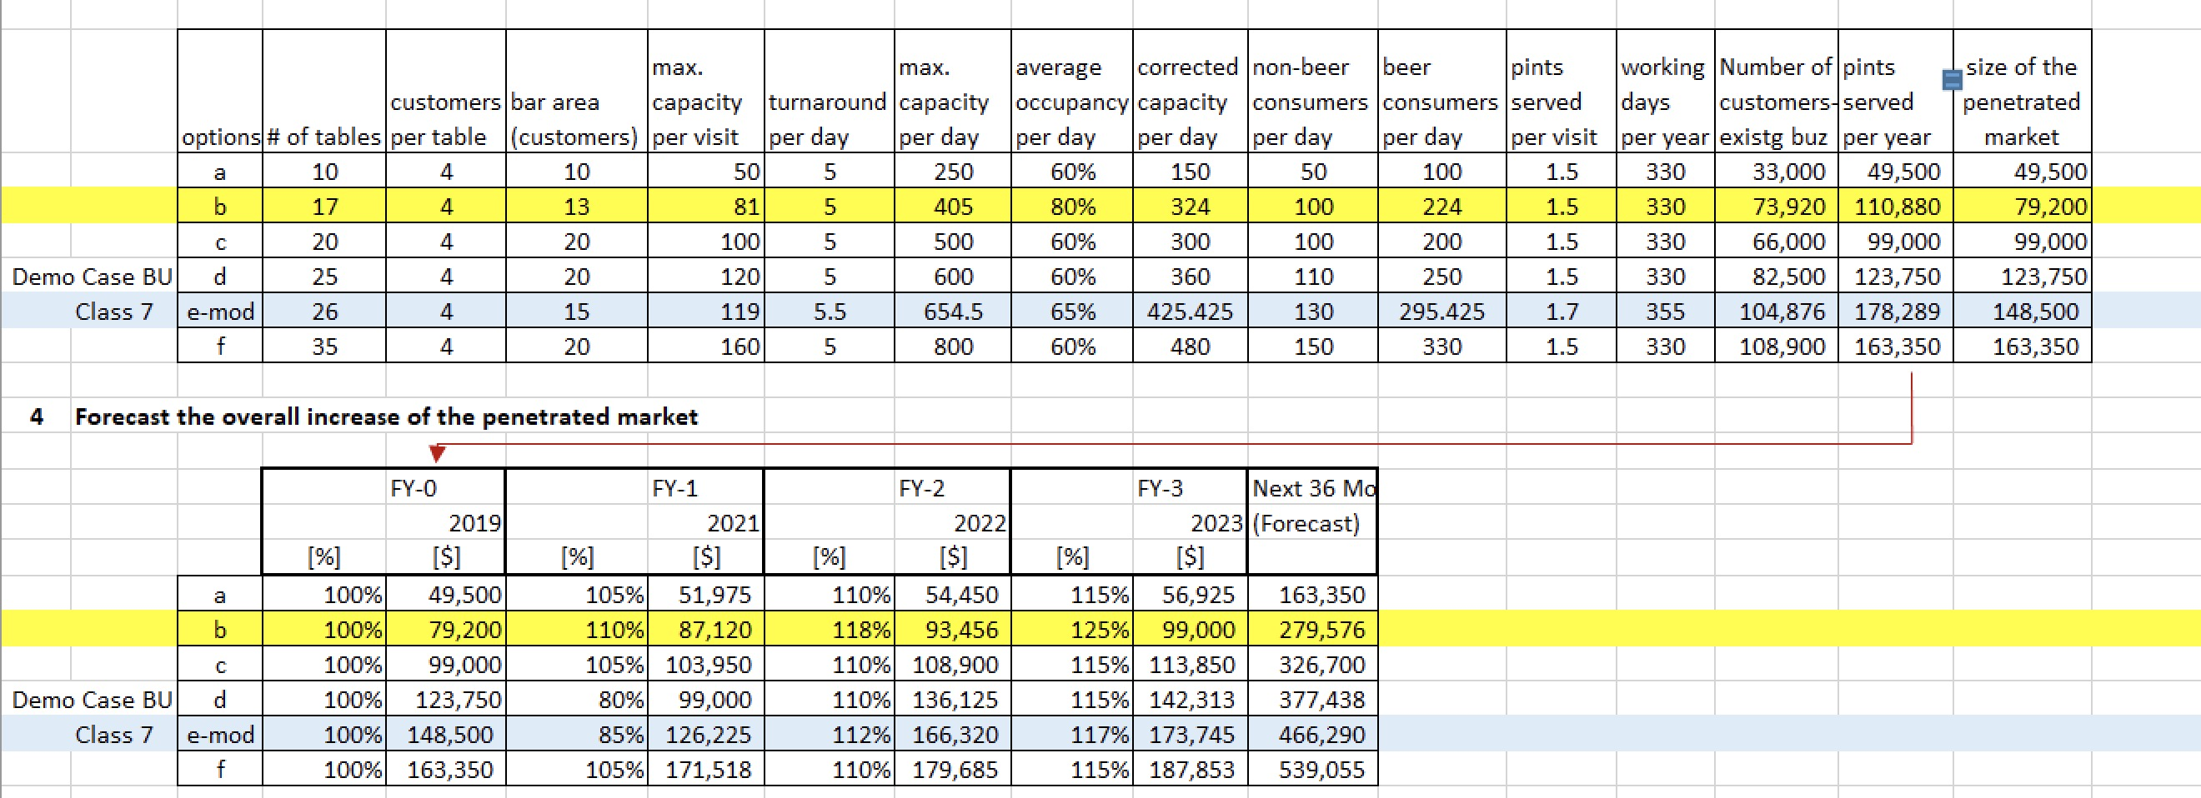
Appendix 2
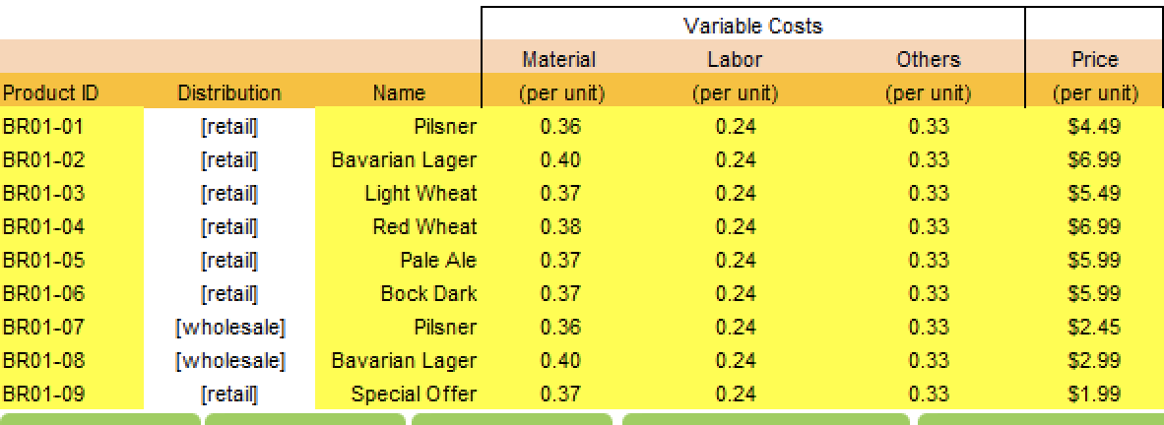
Appendix 3
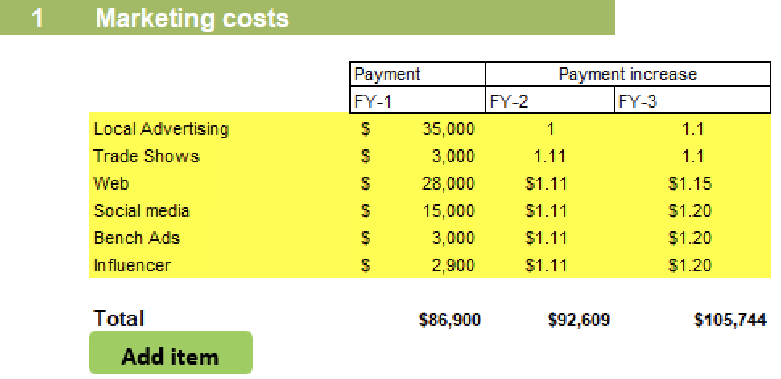
Appendix 4
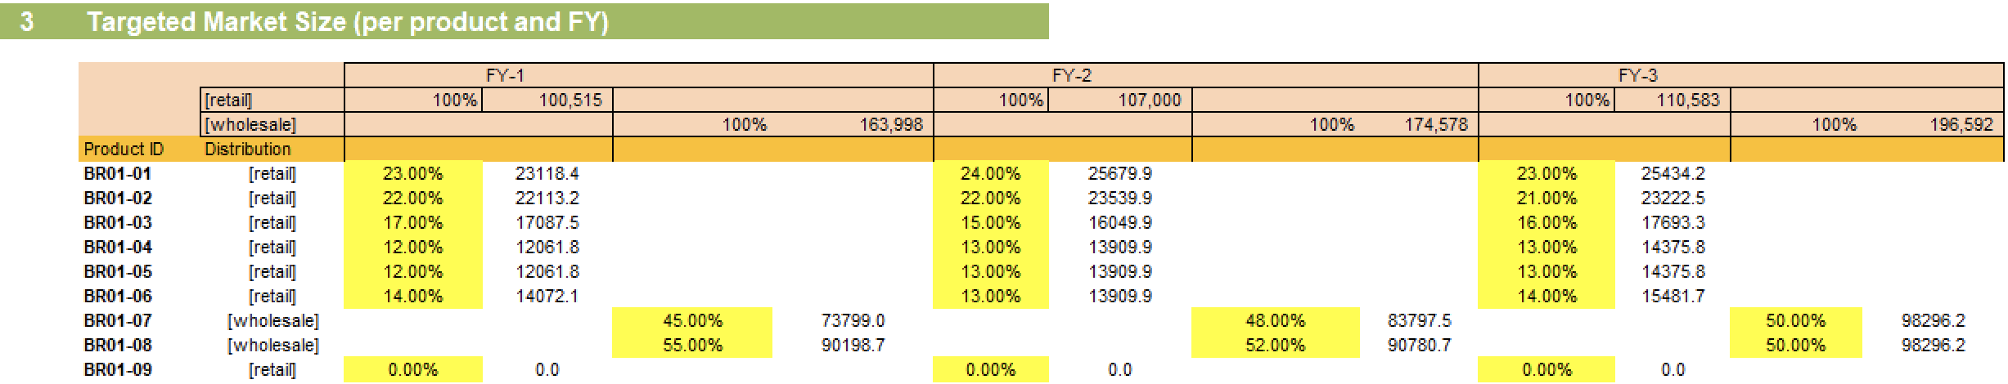
Appendix 5
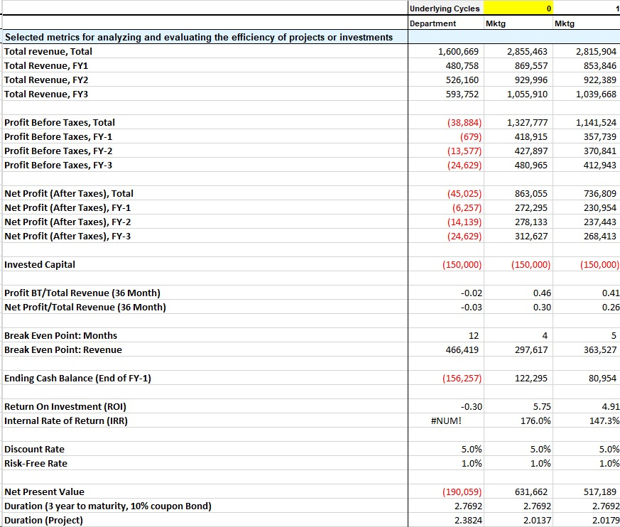
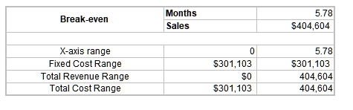
Appendix 6

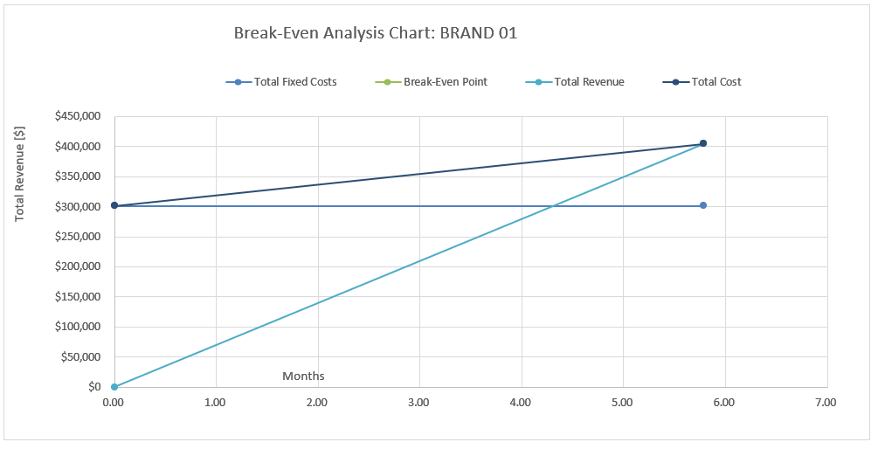
Appendix 7
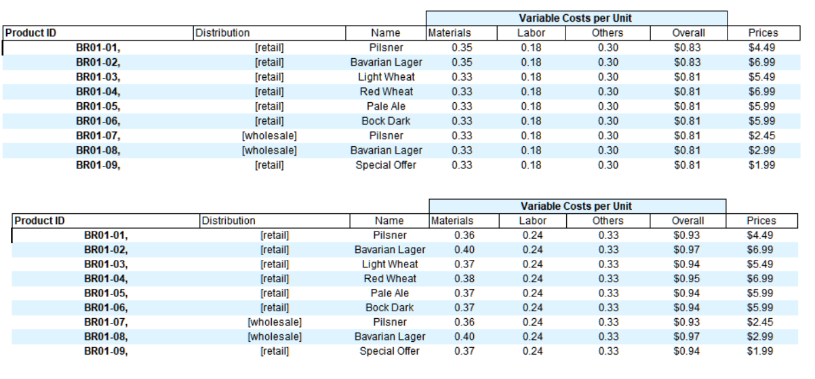
Appendix 8

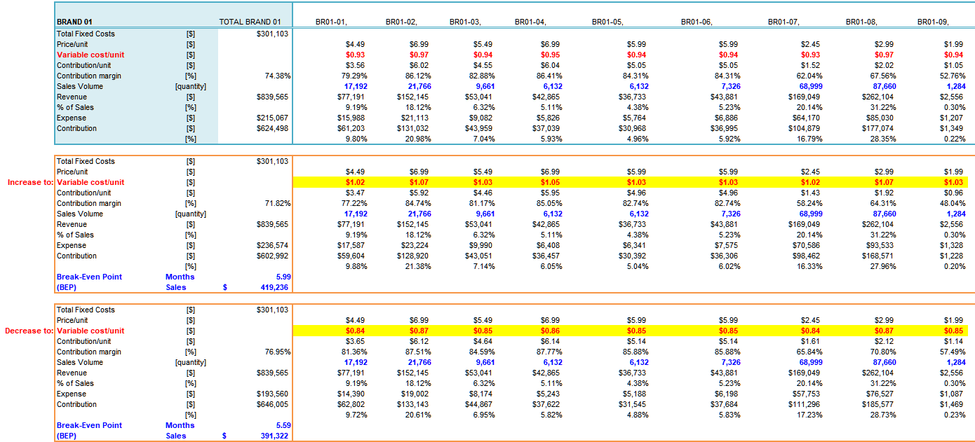
Appendix 9
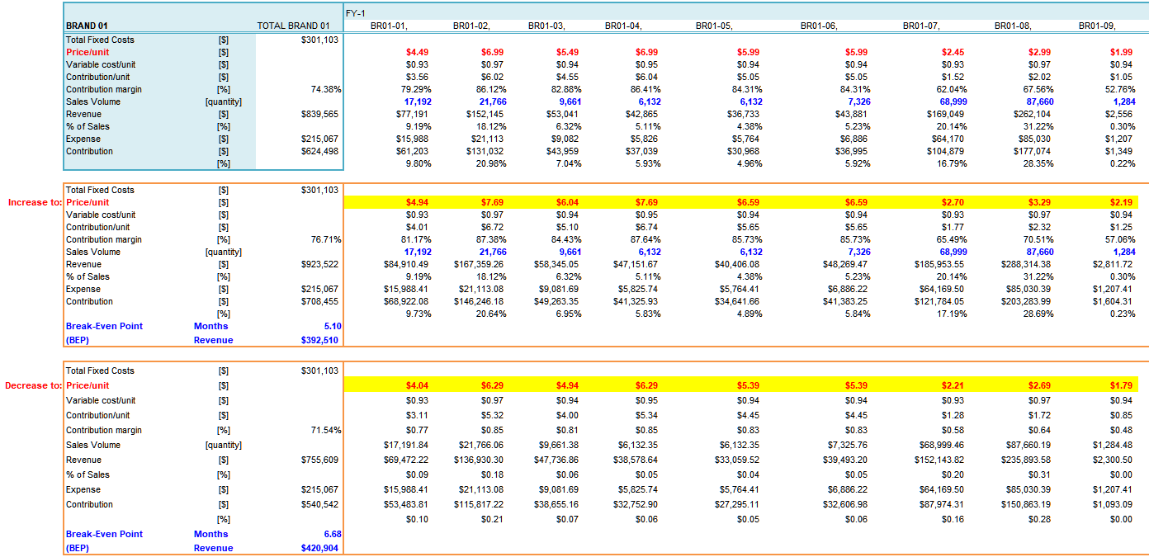
Appendix 10

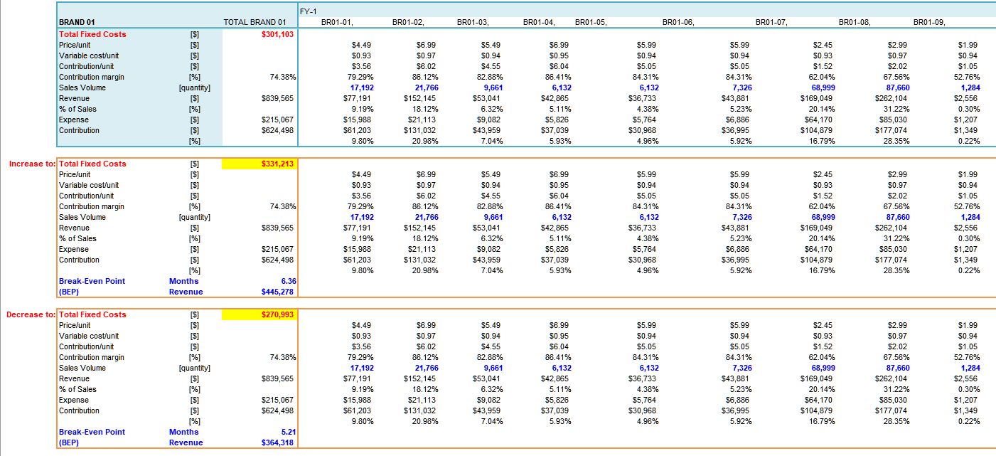
Appendix 11

